INFORMATION MANAGEMENT

**Exercise 7**

1. List the names of 5 youngest employees in the company.

SELECT f_name, l_name FROM employee_data ORDER BY age ASC LIMIT 5;

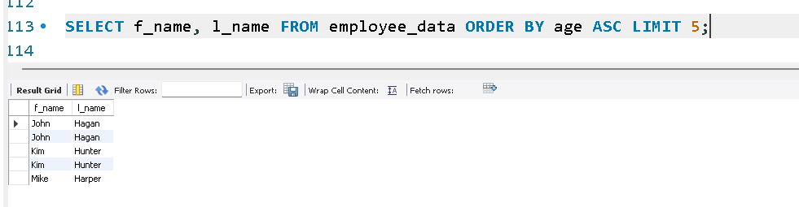

2. Extract the next 5 entries starting with the 10th row.

SELECT f_name, l_name FROM employee_data LIMIT 9,5;

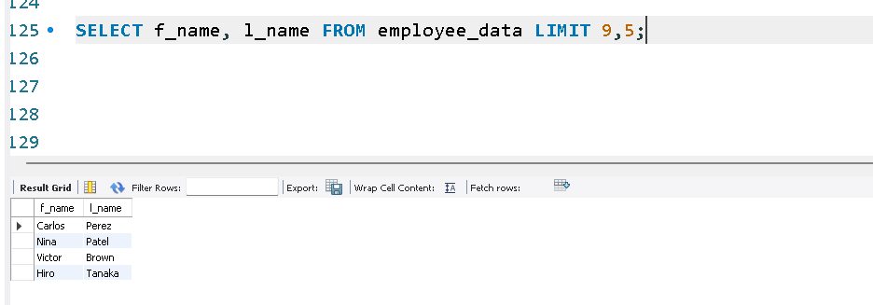

3. Display the names and salary of the employee who draws the largest salary.

SELECT f_name, l_name, salary FROM employee_data ORDER BY salary DESC LIMIT 1;

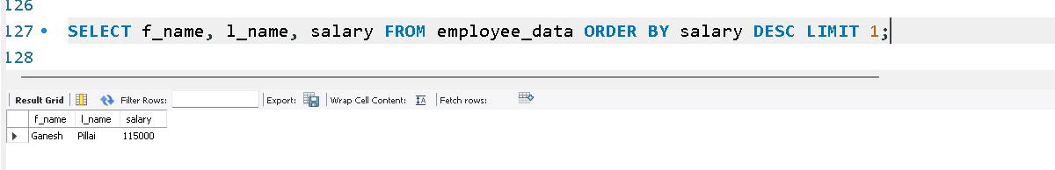

4. What does the following statement display?

SELECT emp_id, age, perks FROM employee_data ORDER BY perks DESC LIMIT 10;

